3.2 Inferential Statistics
Relationship Between Age Demographics and Mobile Wallet Usage

Hypothesis 1: Age Group and Preferred Payment Method

Null Hypothesis (H₀):
There is no significant association between age group and preferred payment method (UPI, Wallet Balance, Debit Card, Credit Card).

Alternative Hypothesis (H₁):
There is a significant association between age group and preferred payment method.

Symbolically:
H₀: Age group and preferred payment method are independent (no association).
H₁: Age group and preferred payment method are not independent (association exists).

Level of Significance:
α = 0.05

Test Statistic:
Chi-Square Test of Independence

Results (SPSS Output):

Case Processing Summary
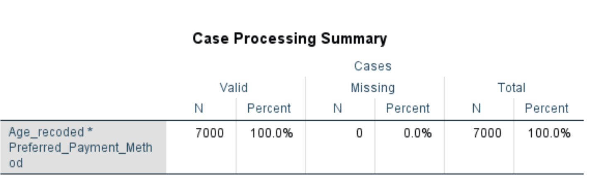
Chi-Square Tests

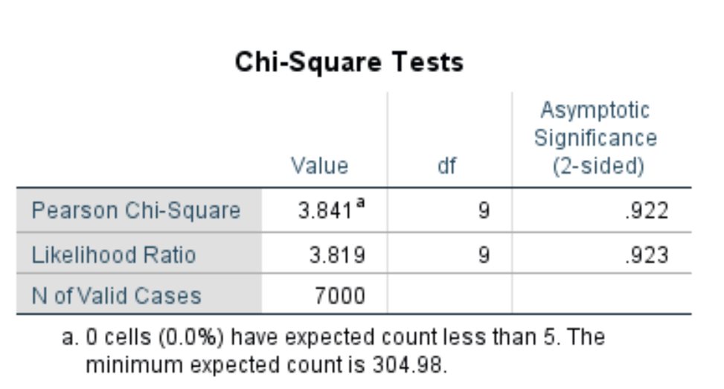
Age Group * Preferred Payment Method Crosstabulation (% within Age Group)
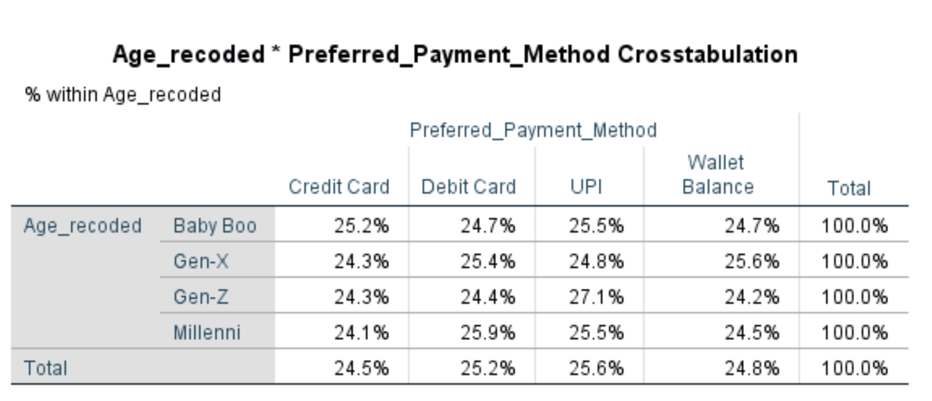
P-value Comparison:
p = 0.922 > α = 0.05
Decision:
Fail to Reject H₀
Conclusion:
The Chi-Square Test of Independence showed χ²(9) = 3.841, p = 0.922. Since the p-value (0.922) is significantly greater than the level of significance (α = 0.05), we fail to reject the null hypothesis. This means that there is no significant association between age group and preferred payment method. In other words, the choice between digital payment methods (UPI and Wallet Balance) and traditional payment methods (Credit Card and Debit Card) does not differ significantly across the four age groups (Gen-Z, Millennials, Gen-X, and Baby Boomers). The row percentage table further supports this finding, as all four age groups show a relatively uniform distribution across all four payment methods, each around 24–27%. Notably, Gen-Z showed the highest UPI usage at 27.1%, suggesting a slight tendency toward digital payments among younger users, though this difference was not statistically significant.

Hypothesis 3: Age Group and Total Transactions

Null Hypothesis (H₀):
μ₁ = μ₂ = μ₃ = μ₄ — Mean total transactions are equal across all age groups.

Alternative Hypothesis (H₁):
At least one age group has a significantly different mean number of total transactions.

Symbolically:
H₀: μ₁ = μ₂ = μ₃ = μ₄
H₁: At least 2 μi ≠ μj

Level of Significance:
α = 0.05

Test Statistic:
One-Way Analysis of Variance (ANOVA)

Results (SPSS Output):

Descriptives: Total Transactions by Age Group
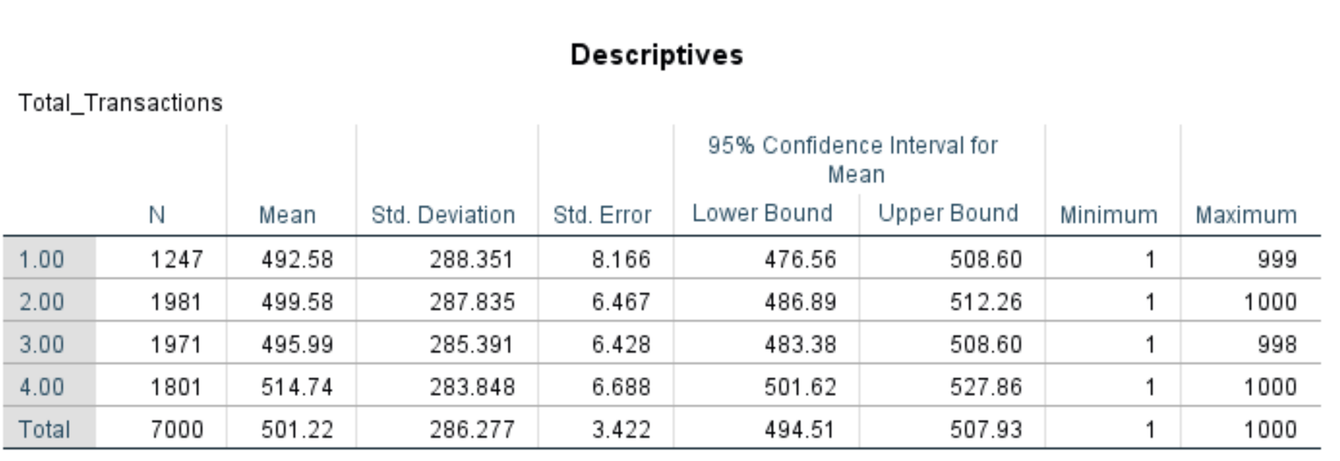
*1 = Gen-z, 2 = Millennials, 3 = Gen-x, 4 = Baby boomers
Test of Homogeneity of Variances (Levene's Test)
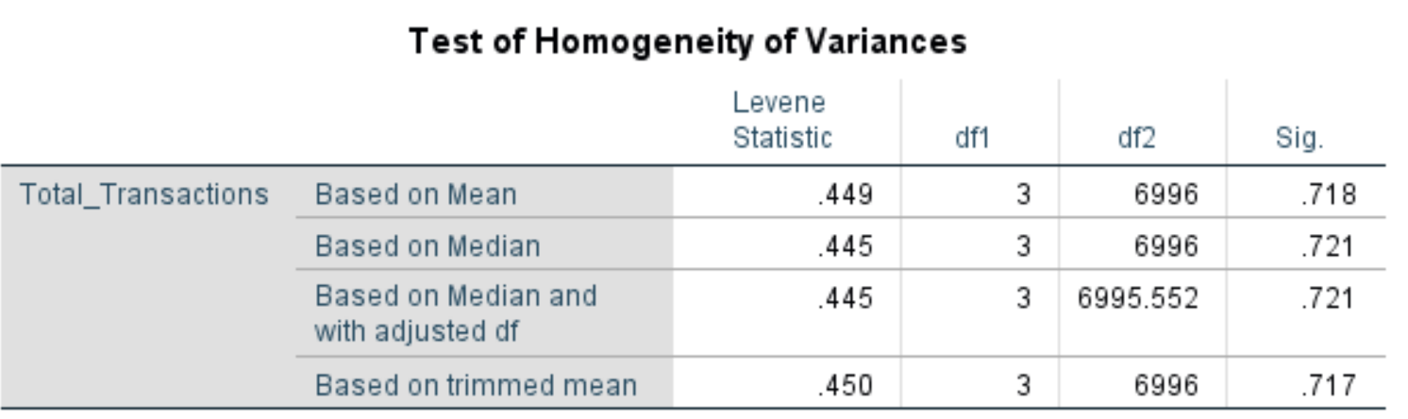Levene's p = 0.718 > 0.05, confirming equal variances across groups. ANOVA assumption satisfied.

ANOVA Table: Total Transactions
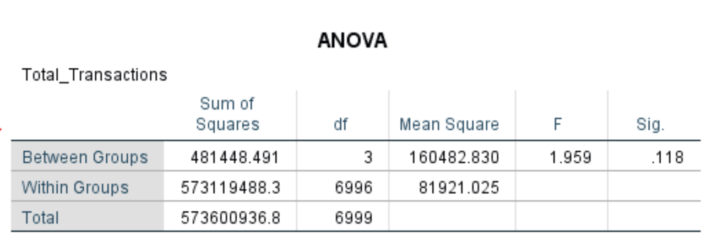
Post Hoc Tests: Multiple Comparisons (Tukey HSD) — Total Transactions
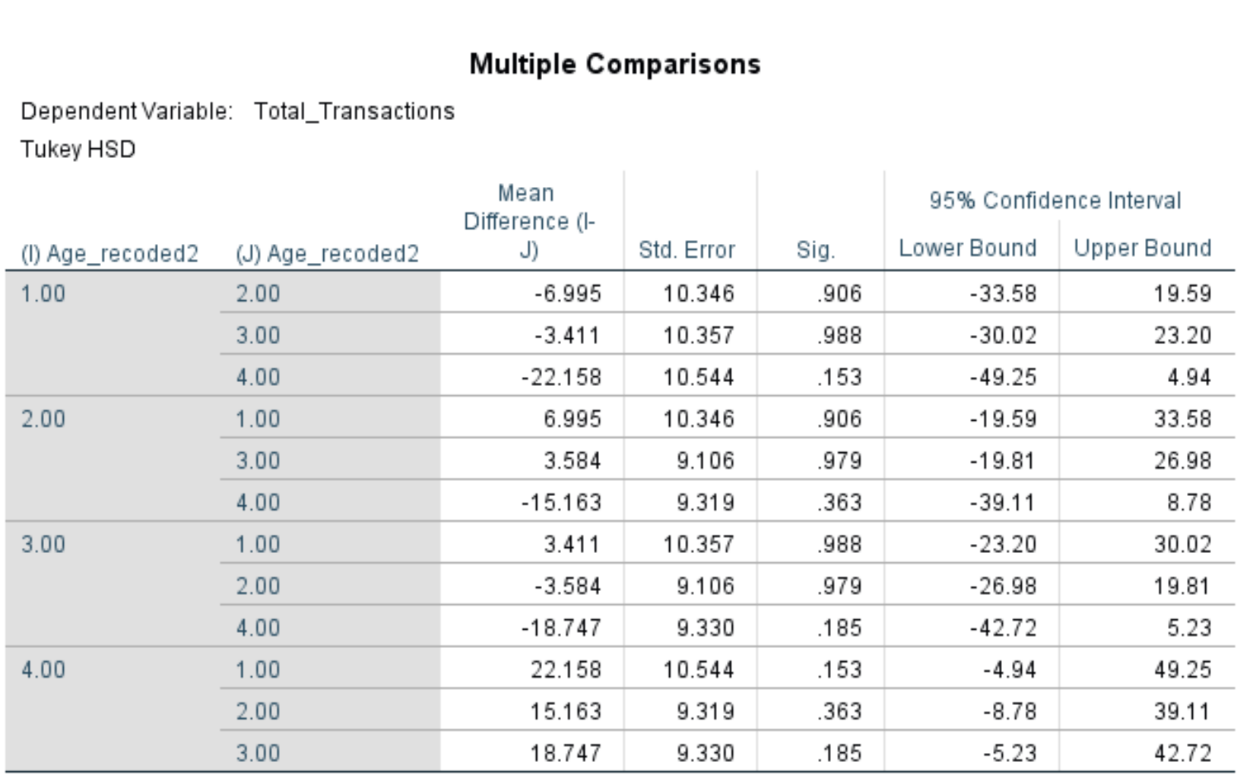
*1 = Gen-z, 2 = Millennials, 3 = Gen-x, 4 = Baby boomers

Group Means Report: Total Transactions and Total Spent by Age Group
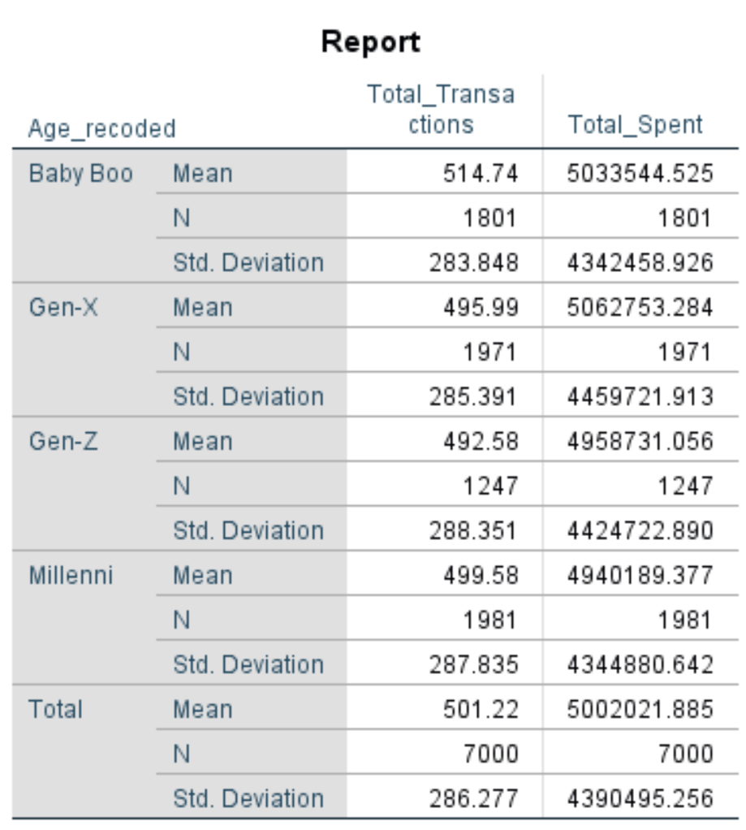
P-value Comparison:
p = 0.118 > α = 0.05
Decision:
Fail to Reject H₀
Conclusion:
The One-Way ANOVA showed F(3, 6996) = 1.959, p = 0.118. Since the p-value (0.118) is greater than the level of significance (α = 0.05), we fail to reject the null hypothesis. This indicates that there is no significant difference in the mean number of total transactions across the four age groups. Before interpreting the ANOVA result, Levene's Test for Homogeneity of Variances was conducted. The result (F = 0.449, p = 0.718) confirmed that the assumption of equal variances was not violated, making the ANOVA result reliable. The descriptive statistics show that Baby Boomers had the highest mean number of transactions (514.74), followed by Millennials (499.58), Gen-X (495.99), and Gen-Z (492.58). However, these differences were not large enough to be statistically significant. The Tukey HSD post hoc test confirmed that no pair of age groups differed significantly from one another, as all pairwise Sig. values exceeded 0.05. The closest comparison was between Gen-Z and Baby Boomers (Mean Difference = -22.158, p = 0.153), suggesting a trending but non-significant difference. Overall, digital wallet transaction frequency appears to be relatively consistent across all age demographics in this dataset.

Overall Summary of Inferential Analysis

Hyp. | Test | Statistic | df | p-value | α | Decision
H1 | Chi-Square (Age Group vs Payment Method) | χ² = 3.841 | 9 | 0.922 | 0.05 | Fail to Reject H₀
H3 | One-Way ANOVA (Age Group vs Total Transactions) | F = 1.959 | 3, 6996 | 0.118 | 0.05 | Fail to Reject H₀

Both hypotheses tested in this study resulted in a failure to reject the null hypothesis. The findings suggest that, within this dataset of 7,000 users, age group does not significantly influence either the preferred payment method or the frequency of total transactions. This may indicate that mobile wallet and digital payment adoption has become relatively uniform across age demographics, or that other variables such as income level or geographic location may be stronger predictors of digital payment behaviour.

